**Vyntra**

Online Cloth Store

The following are major detailed use cases involved in the Online Cloth Store “Vyntra”. Corresponding Use case diagrams are presented.

**Top-level Use case diagram for Online cloth store:**

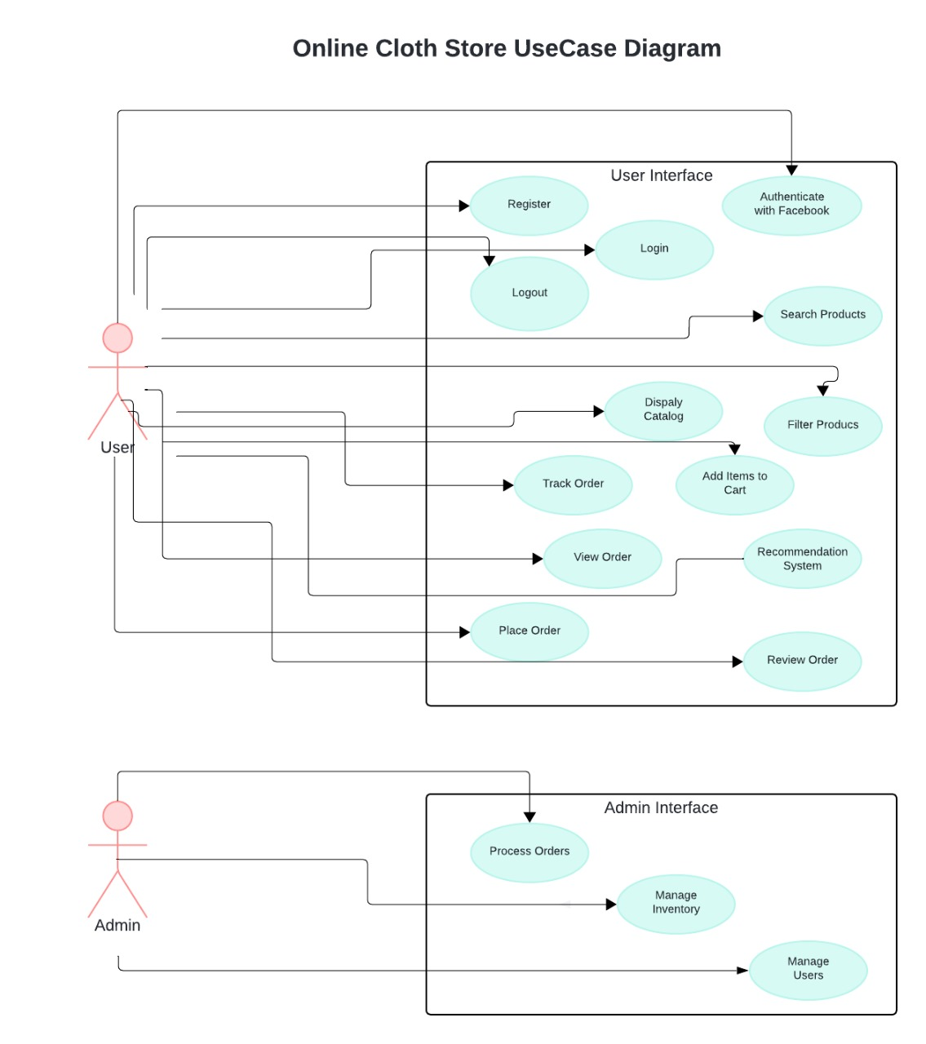

Fig.1: Top Level Use case diagram for Online cloth store

1. User Registration and Authentication:

* Allow users to register using email/password.
* Implement authentication mechanisms for both types of users.
* Enable users to securely log in and log out of the system.

Fig.2: Use Case Diagram for User registration and Authentication process.

2. Product Browsing and Search:

* Display a catalog of trendy clothes with filtering and search functionalities.
* Allow users to browse products by category, brand, size, color, etc.
* Implement a robust search engine with high performance and relevance.

Fig.3: Use Case Diagram for Product Browse and Search process.

3. Shopping Cart (eCart):

* + Enable users to add items to their shopping cart while browsing.
  + Allow users to view and modify the contents of their shopping cart.
  + Implement features such as quantity adjustment, removal of items, and subtotal calculation.

Fig.4: Use Case diagram for Shopping cart (eCart) process.

4. Order Management:

* Provide users with the ability to place orders securely.
* Allow users to review and confirm their orders before checkout.
* Implement order tracking functionality for users to monitor the status of their orders.

Fig.5: Use case diagram for Order Management process.

5. Payment Gateway Integration:

* + Integrate multiple payment gateways, including Gateway1 and PayPal, to facilitate secure and convenient transactions.
  + A diagram of a payment process

    Description automatically generatedEnsure seamless payment processing for users during checkout.

Fig.6: Use case diagram for payment processing.

Fig. 7: Use case diagram Payment Gateway Integration.

6. Admin Interface:

* Provide an intuitive interface for administrators to manage user accounts and product inventory.
* Allow administrators to add, edit, or remove products from the catalog.
* Implement functionalities for inventory management and order processing.

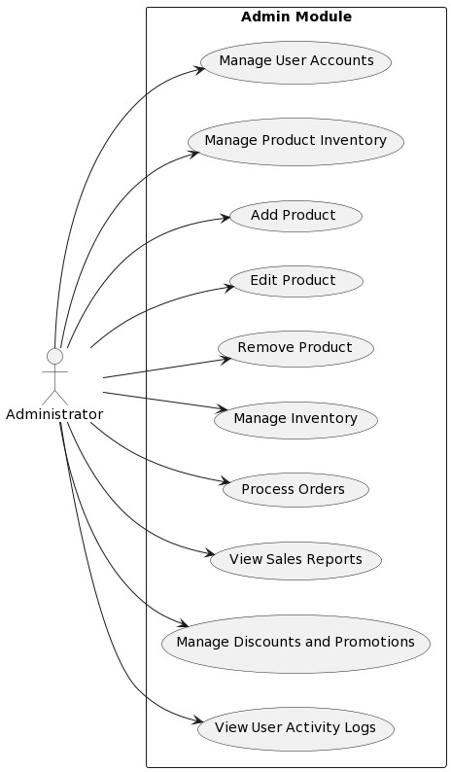

Fig.8: Use case diagram for Admin process.

7. Recommendation Engine:

* + Integrate a recommendation engine to provide personalized product recommendations to users based on their browsing and purchase history.
  + Enhance user experience and increase sales by suggesting relevant items.

Fig.9: Use case diagram for Recommendation of items.

8. Social Media Integration:

* + Enable users to share products and their shopping experiences with their Facebook friends.
  + Implement features for social sharing, commenting, and liking within the application.

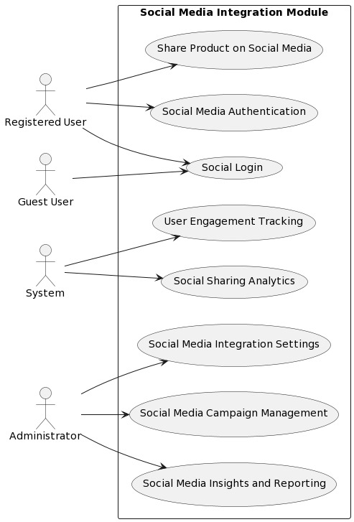

Fig.10: Use case diagram for the Social Media Integration

ScreeenShots

Fig.11: user Registration and Authentication

Fig.12: Product Browse and Search

Fig.13: Product added to cart.

Fig.14: Shipping the Product

Fig.15: Payment gateway

Fig.16:Admin page

Fig.17: Admin Page